## Hazard Identification & Risk Assessment

1. **Purpose**

The purpose of the Hazard Identification and Risk Assessment Procedure is to provide a systematic and objective approach to assessing hazards and minimizing risk associated with those hazards.

1. **Responsibility**

Managers and supervisors are responsible for ensuring that:

* Hazards are identified and assessed in consultation with employees.
* Control measures are implemented where appropriate based on the hierarchy of control.
* Records are maintained of all risk assessments.

Employees are responsible for providing input to risk identification and assessment and following risk control procedures.

1. **Hazard Identification**

Hazard Identification is the process of identifying all situations or events that may expose people to injury, illness, disease or death or may cause damage or loss of equipment and property, or damage to the environment.

The hazard identification process shall be used for routine and non-routine activities as well as new processes, changes in operation, products or services as applicable. Conduct and document regular inspections of all operations, equipment, work areas and facilities for safety hazards.

Identify health hazards including chemical hazards, physical hazards, biological hazards, and ergonomic risk factors by conducting qualitative exposure assessments and reviewing employee medical records.

Workplace incidents including injuries, illnesses, near misses, and stop work interventions should be investigated to identify the root cause in order to prevent future occurrences.

Employees and sub-contractors shall be continually involved in the identification of hazards. Unidentified hazards are to be reported immediately and assessed for risk.

Hazards can be identified through the following methods:

* Internal Audits
* Employee reporting
* Incident and near miss report forms
* Material Safety Data Sheets
* JSA’s
* Manufacturer Recommendations
* Permits to Work

1. **Risk Assessment**

Each hazard that is identified shall be assigned a priority ranking to determine how likely it is that someone could be harmed by the hazard and what the consequence of the resulting injury or illness could be. Each identified hazard shall be recorded on the Hazard Assessment Checklist.

When determining how likely it is that a person could be exposed to a hazard or hazardous event, consideration shall be given to these “exposure factors”:

* Whether there are any other risk factors that increase the likelihood of exposure?
* How often the person is exposed (frequency)?
* For how long is the person exposed (duration)?
* How many people are exposed?
* The likely dose to which the person is exposed?
* Any recommended exposure levels required by standards or codes.

When assessing the risk associated with any hazard, it is necessary to ask the following questions:

* Who is exposed to the hazard?
* How often are people near the hazard?
* Has this hazard already caused any problems?
* How easily could someone be hurt?
* How common is it for the hazard to cause problems in other workplaces?
* Which factors relating to the hazard need to be taken into account, according to health and safety procedures?
* Which factors or specific aspects of the work are increasing the likelihood of injury or illness?

Following risk assessment steps each risk assessed becomes classified as low, medium or high in accordance with the Risk Assessment Matrix shown below.

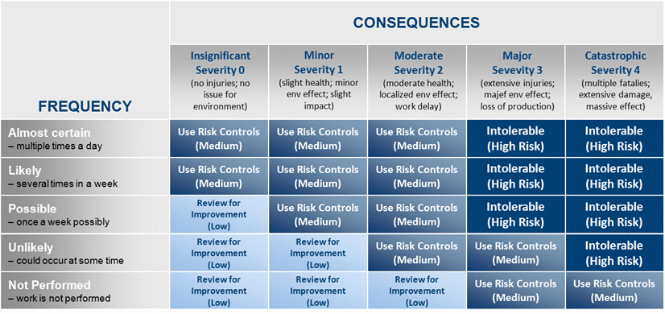

1. **Risk Control**

Risks shall be mitigated using the following controls in the order as listed:

* Eliminate the hazard: remove it from the workplace
* Substitute the hazard: substitute a substance, method or material to reduce the risk or the hazard
* Isolate or enclose the hazard: separate the hazard from the workplace.
* Lock out procedures on faulty equipment.
* Appropriate guarding for machinery.
* Use engineering solutions: modify existing machinery or purchase different machinery.
* Administrative Procedures: develop work methods to reduce the conditions of risk
* (Written Safe Operating Procedures )
* Job rotation to restrict hours worked on difficult jobs.
* Employer and Employees trained in the correct operating procedures.
* Use Personal Protective Equipment (PPE) and training where the hazard cannot be removed or reduced by any other means.

Each measure must have a designated person and date assigned for the implementation of controls using the Hazard Assessment Corrective Action form.

1. **Training**

Managers, supervisors, and employees shall receive training in hazard and risk management procedures prior to performing work. Training shall include the following:

* Workplace hazards and how to identify, report, and control them.
* Proper procedures for performing job.
* Proper use and care of any PPE which may be required to perform work.
* While performing work periodic review of the hazard assessment and
* Any other training that maybe required while performing work.

|  |  |  |  |
| --- | --- | --- | --- |
| **Hazard Assessment Checklist** | | | |
| **Assessment Location: Date & Time:** | | | |
| **Conducted By:** Name Position  __________________________ _______________________    __________________________ _______________________ | | | |
| Item # | Status Priority | Identified Hazards | Specific Location of Hazard |
| 1 |  |  |  |
| 2 |  |  |  |
| 3 |  |  |  |
| 4 |  |  |  |
| 5 |  |  |  |
| 6 |  |  |  |
| 7 |  |  |  |
| 8 |  |  |  |
| 9 |  |  |  |
| 10 |  |  |  |
| 11 |  |  |  |
| 12 |  |  |  |
| 13 |  |  |  |
| 14 |  |  |  |
| 15 |  |  |  |

|  |  |  |  |  |  |
| --- | --- | --- | --- | --- | --- |
| **Hazard Assessment Corrective Action** | | | | | |
| **Assessment Location: Time/Date:** | | | | | |
| **Department/Areas Covered:** | | | | | |
| **Assessment Team:** | | | | | |
| Item # | Priority | Recommended Action | Action Taken/Date/Time | By Whom |  |
|  |  |  |  |  |  |
|  |  |  |  |  |  |
|  |  |  |  |  |  |
|  |  |  |  |  |  |
|  |  |  |  |  |  |
|  |  |  |  |  |  |
|  |  |  |  |  |  |
| **Action Items Sent To :** | | | **Information:** | | |
| **Safety Coordinators Signature:** | | | **Date:** | | |